## Summary

EII would like you, the applicant, to create a word counting program.

If you do not have it already, you can download Visual Studio Community to create this program.

This program typically does not take more than an hour or two to complete.

Keep in mind that this test is meant to demonstrate your ability to create maintainable code that can be understood and refined by others.

## Goal

We would like to see source code for a program that can open a text file, display its contents and allow the user to see a count for each word. ***Create this program as a WPF.***

Below are some screenshots of an example program.

## Example

### 1 - Main Window

This picture shows my main window.

Figure - Main window

All of the boxes are non-editable so the user can’t mess with them.

### 02 - Browse Dialog

Figure - Browse Dialog

This dialog appears when the user presses the “Browse…” button on the main window.

### 03 - File Shown

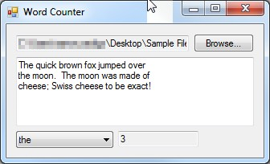

Figure - File Shown

After the file is chosen on the browse dialog, the file name and the file contents are shown.

The text box to the right of the combobox shows the number of times the word is found in the file.

We lowercase all words and remove all punctuation, that is why “the” is found 3 times.

### 04 - Combobox Expanded

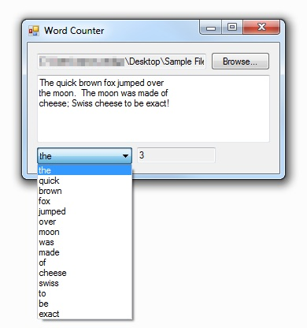

Figure - Combobox Expanded

The combo box is also populated with each word once.

### 05 - Moon Chosen

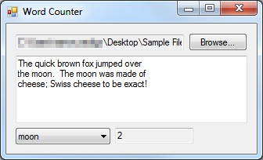

Figure - Moon Chosen

This shows that “moon” and “moon.” both count as just “moon”.